ASSIGNMENT 9  ERROR CORRECTION | Name: Nivetha Dhanakoti  Reg no.: 3122 22 5001 087

Aim:
To be proficient in developing an application to simulate error correction using hamming code technique using socket programming in C

Write the code using socket programming in C
1. Establish the basic connection between client and the server.
2. Develop an application to simulate error correction using hamming code technique.
3. Client gets input data from user.
4. Find the number of bits to be transmitted.
5. Find the redundant code to be generated depending on the number of bits in the data.
6. Compute the value of r bits.
7. Embed “r” bits in data and send the data to the server.
8. Server will find the r bits and finds whether the data has error or not. If error present, then it will find the location of error.
9. Correct the data if it contains error and display it.

Server Code:
#include <stdio.h>
#include <stdlib.h>
#include <string.h>
#include <unistd.h>
#include <arpa/inet.h>

void checkAndCorrectHammingCode(int hammingData[], int m, int r);

int main() {
int serverSock, newSock;
struct sockaddr_in serverAddr, clientAddr;
socklen_t addr_size;

// Create socket
serverSock = socket(AF_INET, SOCK_STREAM, 0);
if (serverSock < 0) {
printf("Socket creation failed.\n");
return -1;
}

// Configure server address
serverAddr.sin_family = AF_INET;
serverAddr.sin_port = htons(8080);
serverAddr.sin_addr.s_addr = INADDR_ANY;

// Bind socket to the port
if (bind(serverSock, (struct sockaddr *)&serverAddr, sizeof(serverAddr)) < 0) {
printf("Bind failed.\n");
return -1;
}

// Start listening for connections
if (listen(serverSock, 5) < 0) {
printf("Listen failed.\n");
return -1;
}

printf("Server listening on port 8080...\n");

// Accept incoming connection
addr_size = sizeof(clientAddr);
newSock = accept(serverSock, (struct sockaddr *)&clientAddr, &addr_size);
if (newSock < 0) {
printf("Connection accept failed.\n");
return -1;
}

// Assume maximum size of data + redundant bits
int m = 4; // Number of data bits (e.g., this can be dynamic depending on client)
int r = 3; // Number of redundant bits
int totalBits = m + r;
int hammingData[totalBits]; // Adjust this size based on the received data

// Receive Hamming code from client
recv(newSock, hammingData, totalBits * sizeof(int), 0);
printf("Received Hamming code from client.\n");

// Check for errors and correct the data if necessary
checkAndCorrectHammingCode(hammingData, m, r);

// Close connection
close(newSock);
close(serverSock);
return 0;
}

void checkAndCorrectHammingCode(int hammingData[], int m, int r) {
int errorPos = 0, i, j;

// Calculate the parity bits to detect error
for (i = 0; i < r; i++) {
int x = 1 << i;
int parity = 0;
for (j = x; j <= m + r; j += 2 * x) {
for (int k = j; k < j + x && k <= m + r; k++) {
parity ^= hammingData[k - 1];
}
}
if (parity != 0)
errorPos += x;
}

// If error detected, correct the error
if (errorPos != 0) {
printf("Error detected at position: %d\n", errorPos);
hammingData[errorPos - 1] ^= 1; // Flip the bit to correct error
printf("Corrected Hamming code: ");
} else {
printf("No errors found\n");
printf("Hamming code: ");
}

// Display the corrected or unchanged Hamming code
for (i = 0; i < m + r; i++) {
printf("%d", hammingData[i]);
}
printf("\n");
}

Client Code:
#include <stdio.h>
#include <string.h>
#include <unistd.h>
#include <arpa/inet.h>

void generateHammingCode(int data[], int m, int r, int hammingCode[]);

int main() {
int sock;
struct sockaddr_in serverAddr;
char buffer[1024];

// Create socket
sock = socket(AF_INET, SOCK_STREAM, 0);
if (sock < 0) {
printf("Socket creation error\n");
return -1;
}

serverAddr.sin_family = AF_INET;
serverAddr.sin_port = htons(8080);
serverAddr.sin_addr.s_addr = inet_addr("127.0.0.1");

// Connect to server
if (connect(sock, (struct sockaddr *)&serverAddr, sizeof(serverAddr)) < 0) {
printf("Connection failed\n");
return -1;
}

// Get data bits from the user
int m;
printf("Enter the number of data bits: ");
scanf("%d", &m);

int data[m];
printf("Enter the data bits (0 or 1):\n");
for (int i = 0; i < m; i++) {
printf("Bit %d: ", i + 1);
scanf("%d", &data[i]);
}

// Calculate number of redundant bits
int r = 0;
while ((1 << r) < (m + r + 1)) {
r++;
}

int totalBits = m + r;
int hammingCode[totalBits];

// Generate Hamming code
generateHammingCode(data, m, r, hammingCode);

printf("Hamming code: ");
for (int i = 0; i < totalBits; i++) {
printf("%d", hammingCode[i]);
}
printf("\n");

// Send Hamming code to server
send(sock, hammingCode, totalBits * sizeof(int), 0);
printf("Hamming code sent to server.\n");

// Close the socket
close(sock);
return 0;
}

void generateHammingCode(int data[], int m, int r, int hammingCode[]) {
int totalBits = m + r;
int dataPos = 0;
int parityCount = 0;

// Initialize hammingCode array with data and parity bits
for (int i = 0; i < totalBits; i++) {
// Check if current position is power of 2 (parity bit position)
if ((i + 1) == (1 << parityCount)) {
hammingCode[i] = 0; // Initialize parity bits to 0
parityCount++;
} else {
hammingCode[i] = data[dataPos]; // Place data bits
dataPos++;
}
}

// Calculate parity bits
for (int i = 0; i < r; i++) {
int parityPos = (1 << i); // Position of current parity bit
int parityValue = 0;

// Calculate parity for current position
for (int j = parityPos; j <= totalBits; j += 2 * parityPos) {
for (int k = j; k < j + parityPos && k <= totalBits; k++) {
parityValue ^= hammingCode[k - 1]; // XOR the data bits covered by this parity bit
}
}

hammingCode[parityPos - 1] = parityValue; // Set the parity bit
}
}

Output 1 :

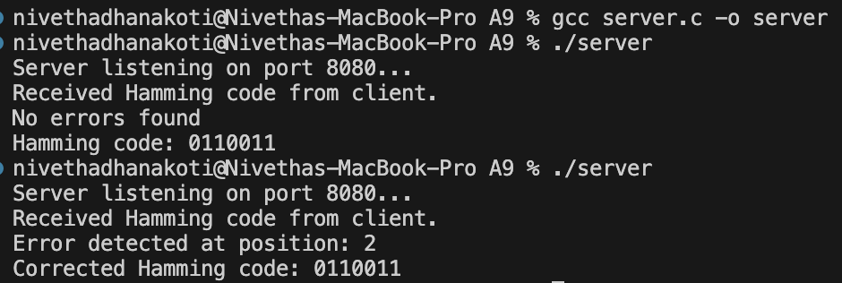

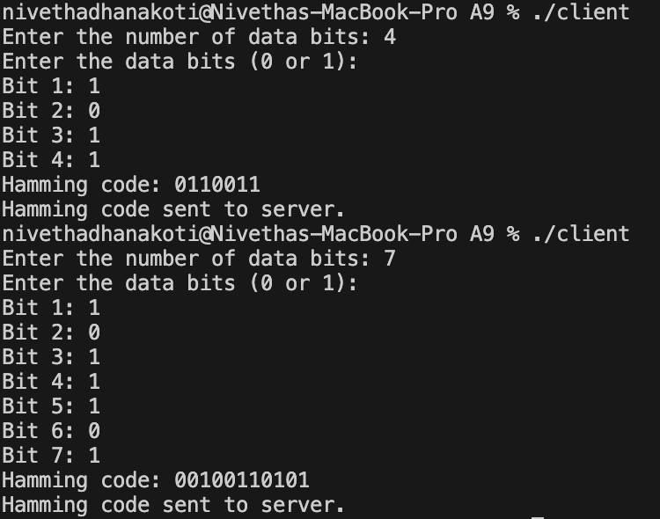

Output 2 :





Learning Outcomes:
I have learnt to be proficient in developing an application to simulate error correction using hamming code technique using socket programming in C

